ASSIGNMENT NO. 1
Identify the Association between Dependent and Independent Variables

Aim
To find out which input variables in a dataset are linked to the output variable, and how strongly, using correlation, p-values and a couple of graphs.

Objectives
- Understand what dependent and independent variables mean.
- Calculate the correlation between each input column and the output.
- Use p-values to check which of these links are real and which could be chance.
- Plot the relations as a heatmap and a scatter plot.

Software and tools
Python 3, written and run in Jupyter Notebook (VS Code works too) on Windows. Libraries used: pandas, matplotlib, scipy and scikit-learn.

Theory

1. Dependent and independent variables
Most data problems have one thing we are trying to predict. That is the dependent variable, also called the target or output. The columns we use to predict it are the independent variables, or features.
Take house prices. The price is the dependent variable. Area, number of rooms and location are independent variables. The price depends on them and not the other way round: a bigger flat costs more, but raising the price doesn't make the flat any bigger.

2. What association means
Two variables are associated when a change in one usually comes with a change in the other. Students who study longer tend to score higher, so study hours and marks are associated.
The link can go either way. Height and weight rise together, which is a positive association. Speed and travel time move in opposite directions, so that one is negative. Some pairs, like shoe size and exam marks, have no link at all.
Association is not the same as cause. Ice cream sales and drowning cases both go up in summer, but ice cream doesn't make anyone drown. Hot weather drives both. In this practical we only measure whether a link exists and how strong it is.

3. Ways to measure it
The right method depends on the kind of data:
- Pearson correlation (r) for two numeric columns with a roughly straight-line relation.
- Spearman rank correlation when the relation curves but keeps going in one direction, or when there are outliers.
- The chi-square test when both columns are categories, for example gender and choice of branch.
- Scatter plots and heatmaps, which show the same thing as a picture.

4. Pearson correlation coefficient
Pearson's r is the one used most often:
r = Σ (x − x̄)(y − ȳ) / √[ Σ (x − x̄)² × Σ (y − ȳ)² ]
Here x̄ and ȳ are the means of x and y. The answer always falls between −1 and +1, and can be read roughly like this:
Value of r | Meaning
+0.7 to +1.0 | Strong positive relation
+0.4 to +0.7 | Moderate positive relation
+0.1 to +0.4 | Weak positive relation
about 0 | No straight-line relation
−0.1 to −1.0 | Same scale, but in the negative direction

5. The p-value
Even two columns of random numbers will show a small correlation now and then, purely by luck. The p-value is the chance of seeing a correlation this strong if there were really no link. When it is below 0.05, we treat the link as statistically significant.

Dataset used
We used the diabetes dataset that comes with scikit-learn. It has 442 patients and 10 input columns: age, sex, bmi (body mass index), bp (average blood pressure) and s1 to s6, which are six blood test readings. The target column is a number showing how far the disease had progressed one year after the tests.
The input values look odd (age shows up as 0.038, for example) because scikit-learn has already scaled them. Scaling doesn't change correlation, so we used them as they are.

Procedure
- Import pandas, matplotlib, scipy and the dataset loader.
- Load the diabetes data as a pandas DataFrame.
- Print its shape and first five rows.
- Build the correlation matrix with df.corr().
- Sort each input's correlation with the target from highest to lowest.
- Run pearsonr() from scipy on each input to get r and its p-value.
- Draw a heatmap of the whole correlation matrix.
- Draw a scatter plot of bmi, the strongest input, against the target.
- Note what the results show.

Program
# Assignment 1 - Association between dependent and independent variables
import pandas as pd
import matplotlib.pyplot as plt
from scipy import stats
from sklearn.datasets import load_diabetes

pd.set_option('display.width', 150)
pd.set_option('display.max_columns', None)

# load the diabetes dataset as a table
data = load_diabetes(as_frame=True)
df = data.frame # 10 input columns + 'target' column
print("Shape of data:", df.shape)
print(df.head().round(3))

# correlation of every input column with the target
corr = df.corr()
print("\nCorrelation with target (highest to lowest):")
print(corr['target'].drop('target').sort_values(ascending=False).round(3))

# Pearson r and p-value for each column
print("\nColumn r value p value")
for col in data.feature_names:
r, p = stats.pearsonr(df[col], df['target'])
print(f"{col:6s} {r:7.3f} {p:.4f}")

# heatmap of the whole correlation matrix
plt.figure(figsize=(7, 6))
plt.imshow(corr, cmap='coolwarm', vmin=-1, vmax=1)
plt.colorbar()
plt.xticks(range(len(corr)), corr.columns, rotation=90)
plt.yticks(range(len(corr)), corr.columns)
plt.title('Correlation Heatmap')
plt.tight_layout()
plt.savefig('a1_heatmap.png')
plt.show()

# scatter plot of the strongest column against the target
plt.figure(figsize=(6, 4))
plt.scatter(df['bmi'], df['target'], s=10)
plt.xlabel('bmi')
plt.ylabel('disease progression (target)')
plt.title('BMI vs Target')
plt.tight_layout()
plt.savefig('a1_scatter.png')
plt.show()

Output
Shape of data: (442, 11)
age sex bmi bp s1 s2 s3 s4 s5 s6 target
0 0.038 0.051 0.062 0.022 -0.044 -0.035 -0.043 -0.003 0.020 -0.018 151.0
1 -0.002 -0.045 -0.051 -0.026 -0.008 -0.019 0.074 -0.039 -0.068 -0.092 75.0
2 0.085 0.051 0.044 -0.006 -0.046 -0.034 -0.032 -0.003 0.003 -0.026 141.0
3 -0.089 -0.045 -0.012 -0.037 0.012 0.025 -0.036 0.034 0.023 -0.009 206.0
4 0.005 -0.045 -0.036 0.022 0.004 0.016 0.008 -0.003 -0.032 -0.047 135.0

Correlation with target (highest to lowest):
bmi 0.586
s5 0.566
bp 0.441
s4 0.430
s6 0.382
s1 0.212
age 0.188
s2 0.174
sex 0.043
s3 -0.395
Name: target, dtype: float64

Column r value p value
age 0.188 0.0001
sex 0.043 0.3664
bmi 0.586 0.0000
bp 0.441 0.0000
s1 0.212 0.0000
s2 0.174 0.0002
s3 -0.395 0.0000
s4 0.430 0.0000
s5 0.566 0.0000
s6 0.382 0.0000

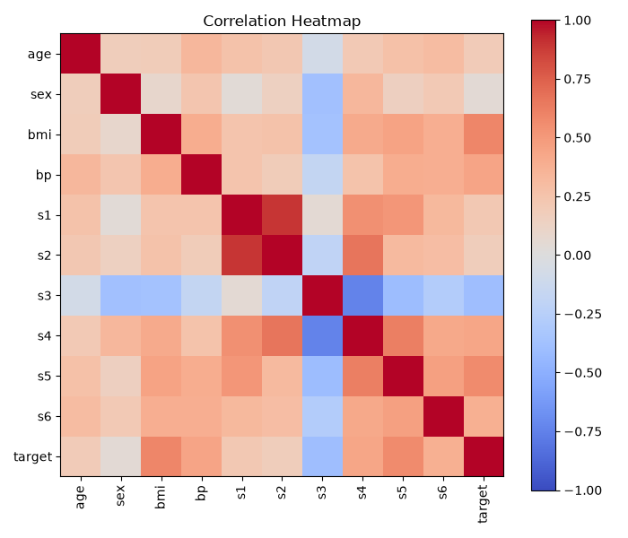
Figure 1.1: Correlation heatmap of all columns
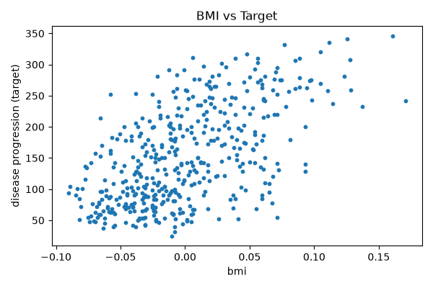
Figure 1.2: BMI against the target

Observations
- bmi has the strongest link with the target (r = 0.586). Patients with a higher BMI generally showed more progression.
- s5 (0.566) and bp (0.441) come next. Both are moderate and positive.
- s3 is the only negative one (r = −0.395). Higher s3 readings went with lower target values.
- sex barely relates to the target (r = 0.043). Its p-value of 0.3664 is well above 0.05, so the link isn't significant.
- All the other inputs have p-values under 0.05.
- The bmi scatter plot slopes upward, as the positive r suggests, but the points are widely spread. BMI on its own can't explain the target.

Conclusion
bmi, s5 and bp are the inputs most closely linked to diabetes progression. s3 has a negative link, and sex has almost none. Checking correlations like this before building a model shows which columns are worth keeping, and it takes only a few lines of code.

